

**NAME:**

**11AEMAM Test 4 2021**

**Section 1: /**

**Section 2: /**

**Total: /**

**%**

**TIME ALLOCATION FOR THIS TEST**

**Section 1 – No Calculators Allowed**

**minutes reading time: 2 minutes**

**minutes working time: 30 minutes**

**Section 2 – Calculators allowed**

**minutes reading time: 1 minutes**

**minutes working time: 22**

**Material required/recommended for this test**

**To be provided by the supervisor**

Question/answer booklets for Sections One and Two.

SCSA 11AEMAM Formulae Sheet

**To be provided by the candidate**

***Section One:***

Standard items: pens, pencils, pencil sharpener, highlighter, eraser, ruler

*Special materials: drawing instruments, templates, notes on a maximum of one unfolded sheet of A4 paper*

**Section Two:**

Standard items: pens, pencils, pencil sharpener, highlighter, eraser, ruler

*Special materials: drawing instruments, templates, notes on a maximum of one unfolded sheet of A4 paper, notes on a maximum of one unfolded sheet of A4 paper, up to three approved calculators, CAS, graphics, or scientific.*

**Important note to candidates**

No other items may be taken into the test room. It is **your** responsibility to ensure that you do not have any unauthorised notes or other items of a non-personal nature in the test room. If you have any unauthorised material with you, hand it to the teacher **before** reading any further.

|  |  |  |  |  |
| --- | --- | --- | --- | --- |
| **Section** | **Reading Time** | **Working time** | **Marks** | **Score** |
| **Resource free** | **2 minutes** | **30** | **30** | **%** |
| **Resource rich** | **1 minutes** | **20** | **21** | **%** |
| **Total** | **3 minutes** | **50** | **51** | **%** |

**Resource Free: 30 minutes**

Question 1 (6 marks)

(a) On the axes below, sketch the graph of , labelling all key features with their coordinates or equations (3 marks)

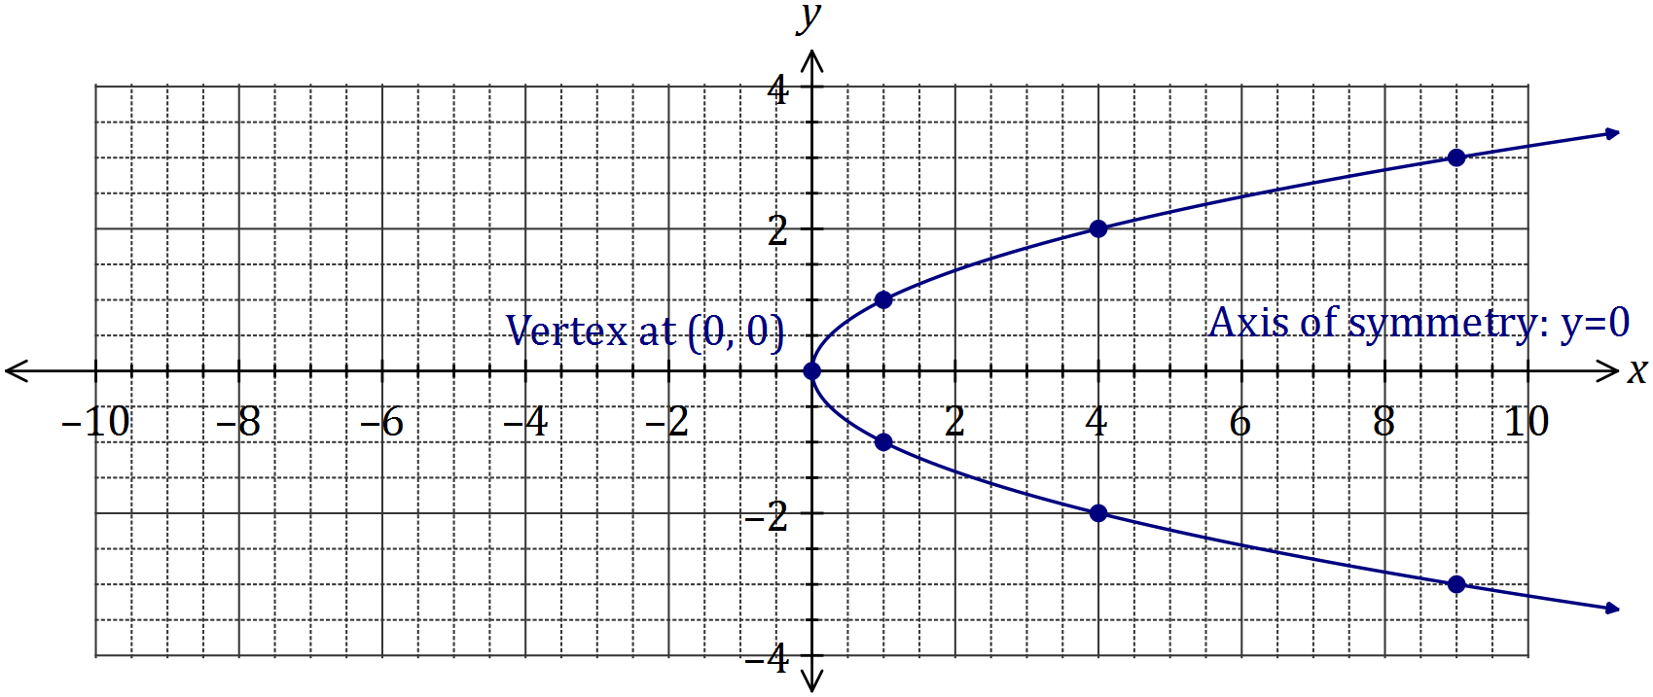

|  |
| --- |
| **Solution** |
| See graph |
| **Specific behaviours** |
| ✓ smooth curve through at least 5 out of 7 marked points  ✓ labels vertex  ✓ labels axis of symmetry |

(b) Determine the equation of the circle shown below (3 marks)

|  |
| --- |
| **Solution** |
|  |
| **Specific behaviours** |
| ✓ uses standard form for circle  ✓ uses correct centre  ✓ uses correct radius |

Question 2 (8 marks)

(a) Solve the equation (4 marks)

|  |
| --- |
| **Solution** |
|  |
| **Specific behaviours** |
| ✓ equates to zero  ✓ factors out  ✓ factors quadratic  ✓ states all solutions |

(b) The graph of is shown below. Determine the values of the constants of and . (4 marks)

|  |
| --- |
| **Solution** |
|  |
| **Specific behaviours** |
| ✓ writes factors from roots  ✓ determines  ✓ expands  ✓ states all values |

Question 3 (8 marks)

|  |
| --- |
| **Solution** |
| From 3-4-5 right-triangle,  From 2--3 right-triangle,  Using identity, |
| **Specific behaviours** |
| ✓ states  ✓ states  ✓ uses identity  ✓ simplifies |

(a) If and are acute angles such that and , determine the value of as a single fraction. (4 marks)

(b) Solve the following equations.

(i) where (2 marks)

|  |
| --- |
| **Solution** |
|  |
| **Specific behaviours** |
| ✓ both solutions located in 3rd and 4th quadrants  ✓ correct angles using radians |

(ii) where given that (2 marks)

|  |
| --- |
| **Solution** |
|  |
| **Specific behaviours** |
| ✓ first solution  ✓ second solution |

Question 4 (5 marks)

(a) Find the exact value of

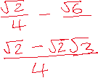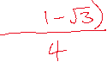

**END OF SECTION ONE**

**Calculator Allowed Section** Name: …………………………………

Reading time: 1 minutes

Working time: 20 minutes Marks: 21

Question 5 (6 marks)

(a) The graphs of and are shown below.

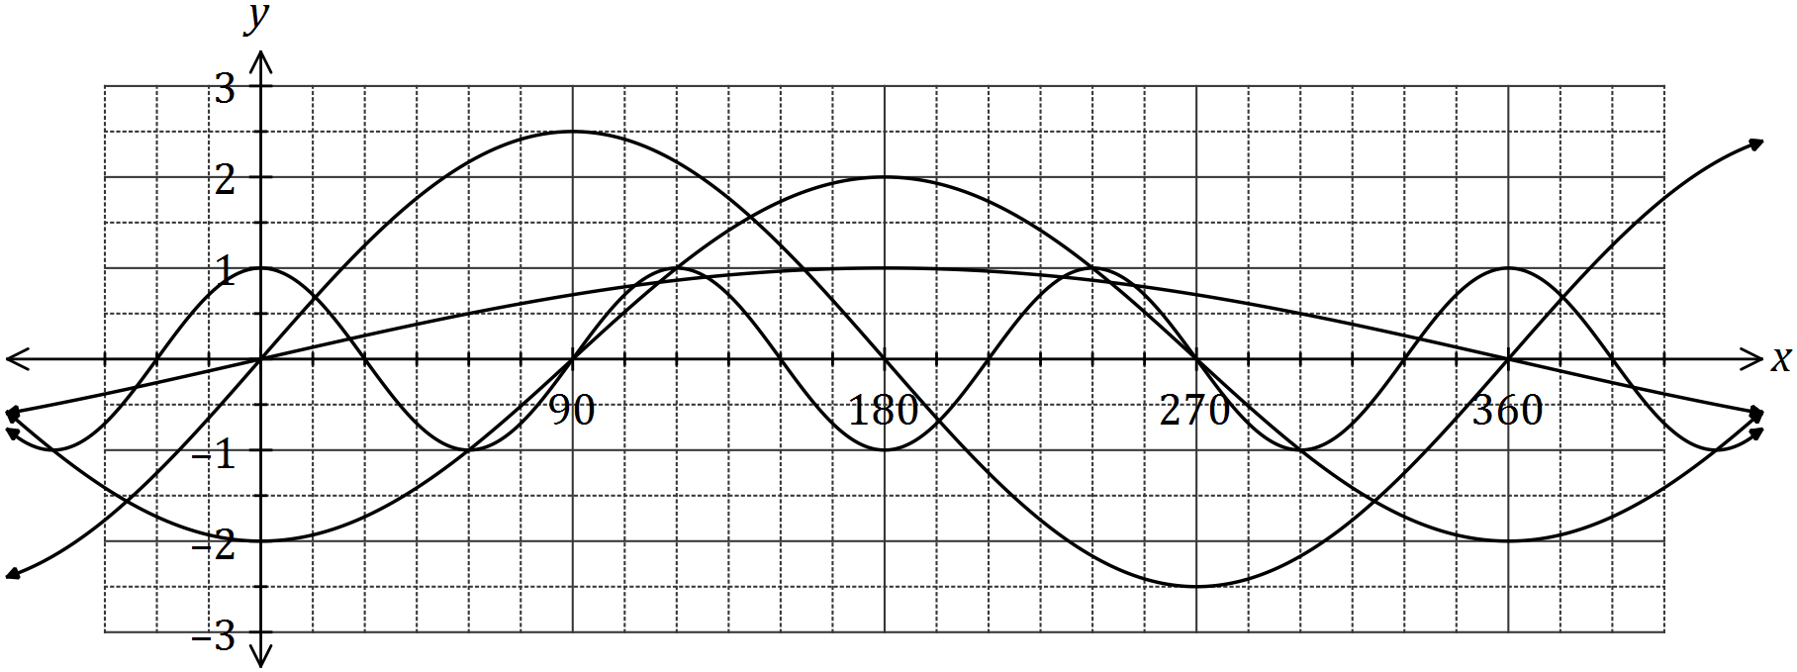

Determine the values of the constants and . (4 marks)

|  |
| --- |
| **Solution** |
|  |
| **Specific behaviours** |
| ✓✓✓✓ one mark per correct value |

(b) The graph of is drawn below.

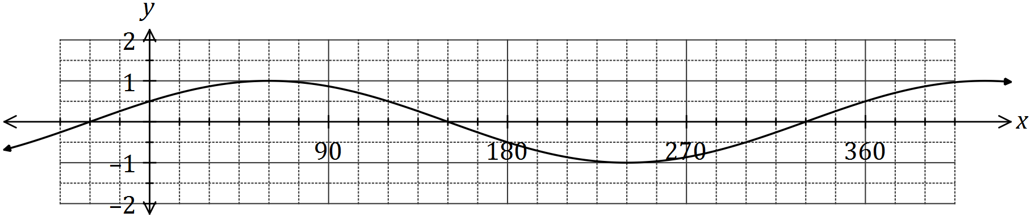

1. State the value of the constant , where . (1 mark)

|  |
| --- |
| **Solution** |
|  |
| **Specific behaviours** |
| ✓ states value |

(ii) The graph is also that of . State the value of the constant , where   
. (1 mark)

|  |
| --- |
| **Solution** |
|  |
| **Specific behaviours** |
| ✓ states value |

Question 6 (7 marks)

Let and , where and are constants.

The graph of is shown below.

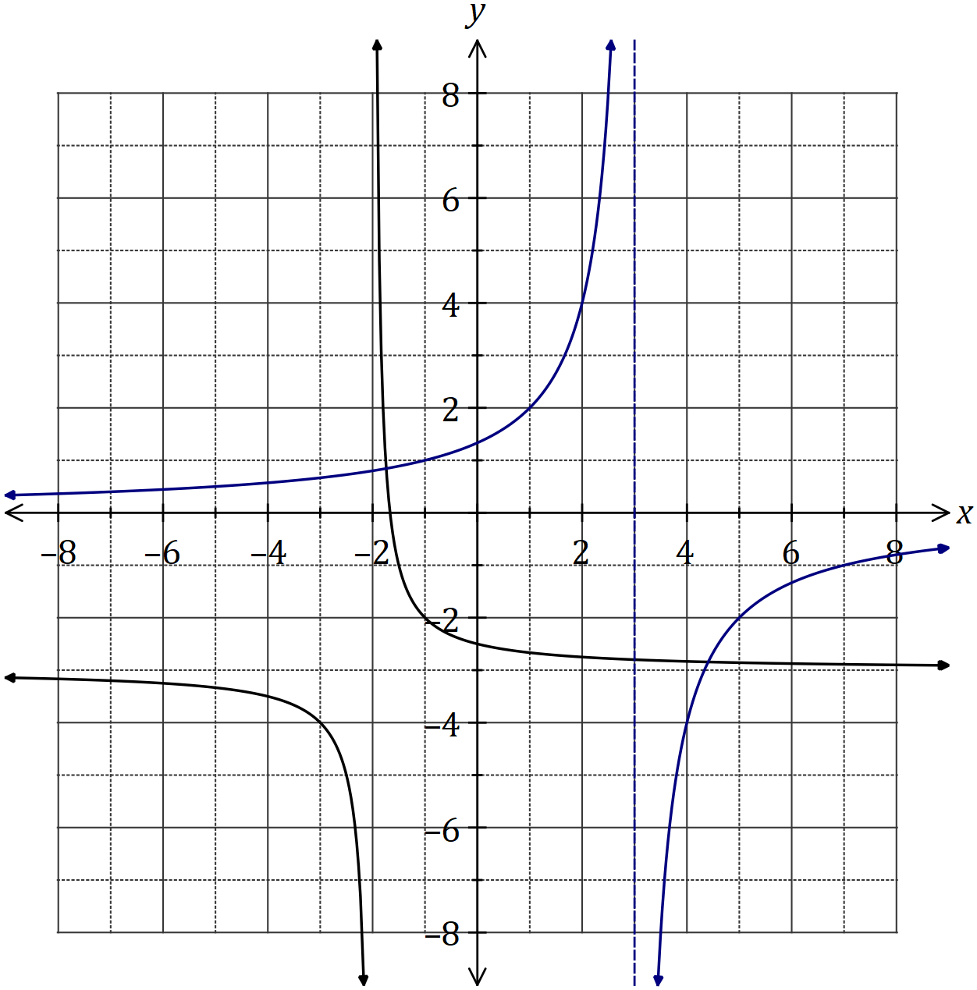

|  |
| --- |
| **Solution** |
| See graph |
| **Specific behaviours** |
| ✓ asymptotes  ✓ y-intercept  ✓ accuracy *[i.e. thru' at least 3 of (-1,1), (1,2), (2,4), (4,-4) or (7,-1)]* |

(a) Sketch the graph of on the axes above. (3 marks)

(b) Determine the values of and . (2 marks)

|  |
| --- |
| **Solution** |
|  |
| **Specific behaviours** |
| ✓ value of  ✓ value of |

(c) Solve the equation , giving your solution(s) to one decimal place. (2 marks)

|  |
| --- |
| **Solution** |
|  |
| **Specific behaviours** |
| ✓ one solution  ✓ second solution  *(Rounding for guidance only but penalise answers given as coordinates)* |

Question 7 (8 marks)

During 2018, the altitude of the sun, degrees, at noon in Melbourne on the day of the year can be modelled by the equation

(a) On the 26th of January, the altitude was . Calculate the altitude ten days earlier.

(2 marks)

|  |
| --- |
| **Solution** |
|  |
| **Specific behaviours** |
| ✓ indicates  ✓ correct angle |

(b) Graph the altitude on the axes below for . (4 marks)

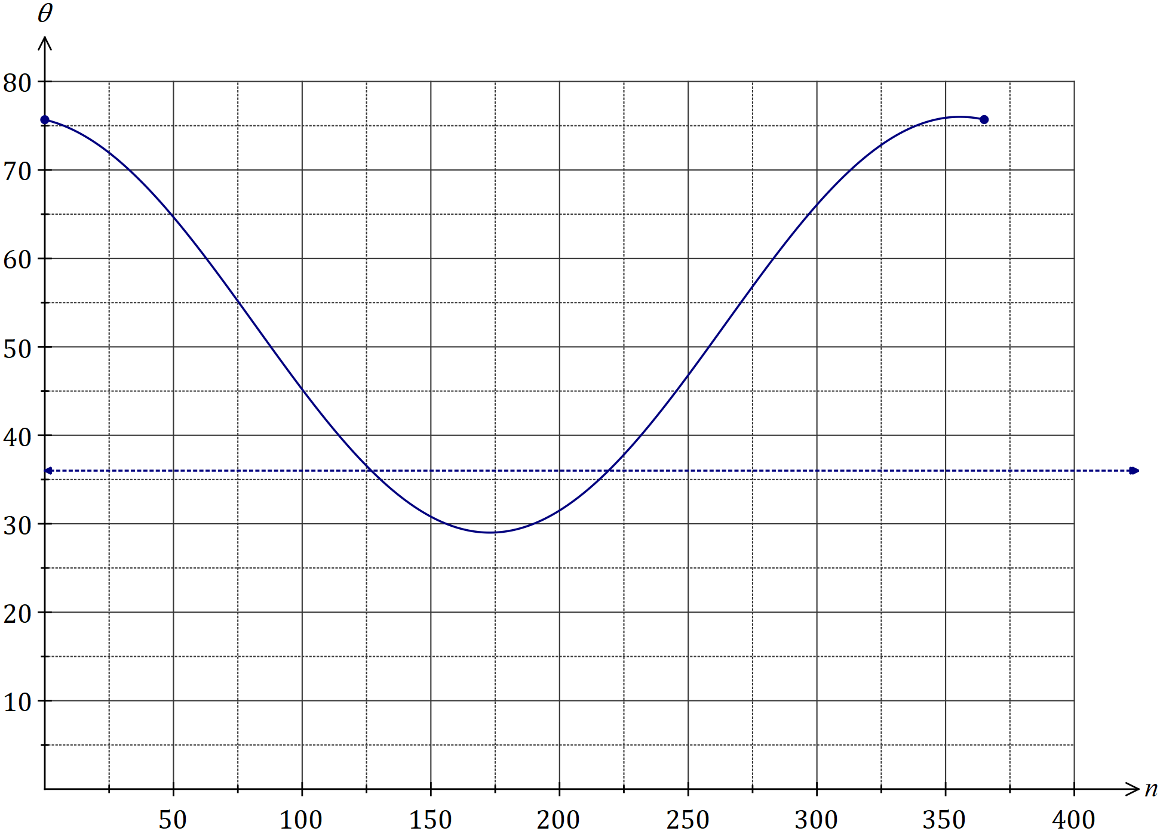

(c) State the minimum altitude of the sun at noon in Melbourne and on which day of the year this occurred. (2 marks)

|  |
| --- |
| **Solution** |
|  |
| **Specific behaviours** |
| ✓ altitude, correct to 1dp  ✓ day of year, rounded to whole number |

**THIS PAGE HAS BEEN LEFT BLANK INTENTIONALLY TO PROVIDE SPACE FOR WORKING IF REQUIRED**

**END OF TEST**